Excecise number 5

Date 14/10/2020

Aim :

To write a python function to find a missing characters

Program :

a=input()

a=set(a.strip())

a.remove(chr(32))

b="abcdefghijklmnopqrstuvwxyz"

b=set(b)

b=b.difference(a)

b=list(b)

b.sort()

print("".join(b))

Link:

<http://103.53.53.18/mod/vpl/forms/edit.php?id=235&userid=1787#>

Output:

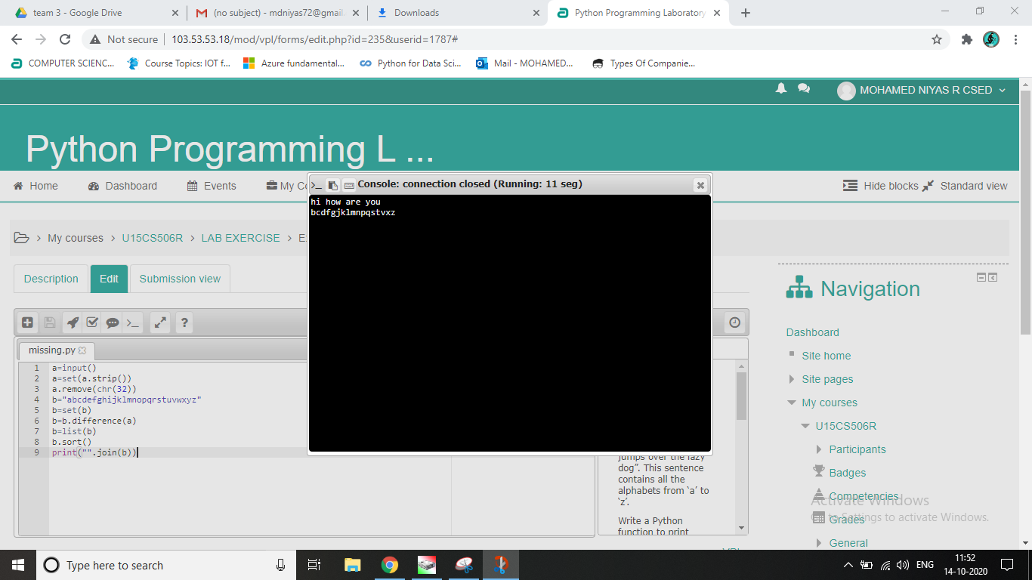

Result :

The program executed correctly.